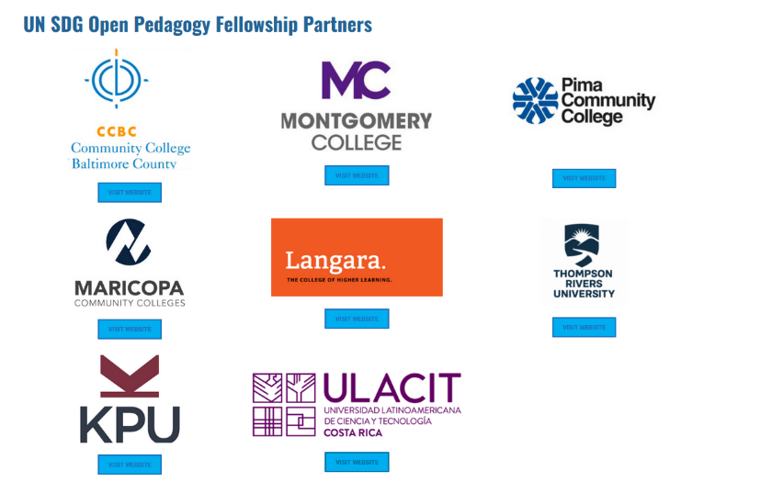
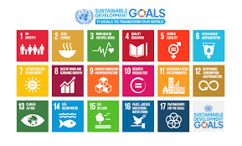

United Nations Sustainable Development Goals
Open Pedagogy Faculty Fellowship
Description

Open educational resources (OER) increase equitable access to education and empower students in the learning process. Open pedagogy – an approach to teaching and learning that draws on OER - places the student at the center of that learning process in a more engaging, authentic, and collaborative learning environment in order to achieve social justice in the community. The partners of the project are committed to supporting social justice through this international partnership in which faculty can work across institutions to maximize global impact.
This global award-winning fellowship provides faculty with an opportunity to work with their colleagues and students to impact change through open pedagogy and community engagement. The conceptual framework on which this fellowship is based is the United Nations Sustainable Development Goals (UN SDGs), which is a set of 17 goals that address a wide range of social issues, such as poverty, inequality, climate change, and peace and justice. The SDGs are designed to achieve and maintain social justice and a sustainable future, with a target of the year 2030 set for the attainment of each goal.
This fellowship is designed to assist faculty with creating renewable assignments (all of which will carry a Creative Commons license) to help students become agents of change in their own communities. Each fellowship team will design three renewable assignments in Summer 2022. A minimum of two renewable assignments will be deployed in the classes of each fellowship team during Fall 2022. Faculty will be expected to present on their proposed assignments prior to their deployment. A student showcase will take place during Spring 2023 in which a select number of students will present on how they improved their communities and achieved global justice through open pedagogy using the UN SDG framework.
Fellowship teams must include 2 to 3 instructors from different disciplines and different institutions so as to maximize student impact. Open Pedagogy Fellows will be required to attend a kick-off meeting and three additional meetings throughout the summer in addition to the following:
Deliverable | Deadline
4 Virtual Meetings 10:00am-1:00 p.m. PST | Tuesday, June 16, 2022  Thursday, June 23, 2022  Tuesday, June 30, 2022  Thursday, August 4, 2022
3 Renewable Assignments submitted | Tuesday, August 29, 2022
Course Data | Friday, November 15, 2022
Faculty Reflection | Friday, December 30, 2022
3-Minute Student Video | Friday, December 30, 2022
Faculty/Student Showcase Presentation (Optional) | TBD in February 2023

TRU faculty interested in becoming a UN SDG Open Pedagogy Faculty Fellow should discuss their interest with the Brenda Smith or Ken Monroe. If selected, you will be partnered with a faculty member(s) from an external partner institution. Communications with faculty partner(s) can be done entirely through web conferencing and/or email. The application, which can be found below, must be completed in its entirety in order to be considered. Completed applications are submitted to kmonroe@tru.ca on midnight on Wednesday, March 31, 2022. Faculty will be notified of acceptance to the fellowship by the week of April 12, 2021.
For questions, you can contact any member of the leadership team:
Thompson Rivers University:
Brenda Smith: brsmith@tru.ca
Ken Monroe: kmonroe@tru.ca
Dr. Michelle Harrison: mharrison@tru.ca

Montgomery College:
Dr. Michael Mills: Michael.Mills@montgomerycollege.edu
Ms. Shinta Hernandez: Shinta.Hernandez@montgomerycollege.edu

Kwantlen Polytechnic University:
Dr. Rajiv Jhangiani: Rajiv.Jhangiani@kpu.ca
Ms. Urooj Nizami: Urooj.Nizami@kpu.ca

Maricopa Community Colleges:
Ms. Deborah Baker: Deborah.Baker@domail.maricopa.edu
Dr. Carla Ghanem: Carla.Ghanem@gatewaycc.edu
Dr. Sian Proctor: Sian.Proctor@southmountaincc.edu
Mr. Matthew Bloom: Matthew.Bloom@scottsdalecc.edu

Pima Community College:
Dr. Josie Milliken: jlmilliken@pima.edu

Community College of Baltimore County:
Ms. Cynthia Roberts-Whitelock: croberts@ccbcmd.edu
Ms. Jamie Witman: jwitman@ccbcmd.edu

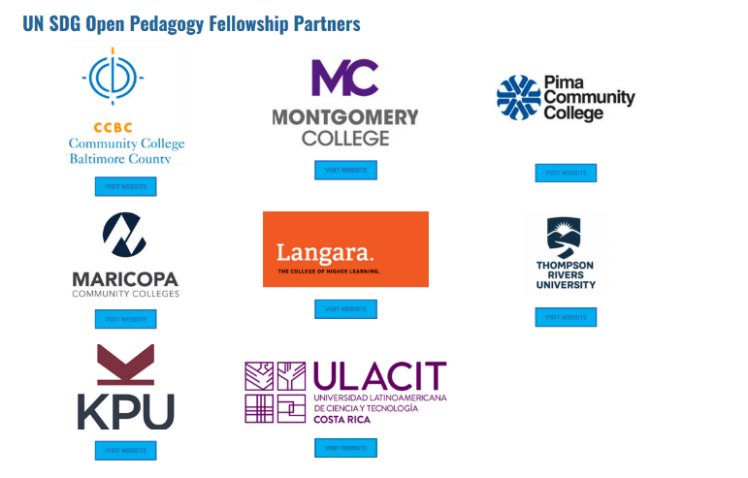

United Nations Sustainable Development Goals
Open Pedagogy Faculty Fellowship Application Form
Summer 2022

INSTRUCTIONS: Fill out this application form. Be sure to read the fellowship description for requirements. Submit the completed application package to kmonroe@tru.ca by midnight Thursday, March 31, 2022.

Part One: Complete the following information.
Faculty Name:
Faculty Email:
Discipline(s):
Proposed course(s):
Proposed SDG(s): having multiple possible goals facilitates pairing with other fellows (to obtain a list of SDGs, refer here):

Part Two: Read the short article, Open Pedagogy by Robin De Rosa and Rajiv Jhangiani and respond to the following prompts in narrative form. The selection committee will use your responses and engagement with this piece to determine the suitability of the fellowship with your current interests and needs.
1. In one paragraph, describe how open pedagogy, as outlined by De Rosa and Jhangiani, might benefit your students in your proposed course(s).
2. In one paragraph, describe how open pedagogy might benefit your discipline.
3. Describe other reasons why you would be interested in becoming a UN SDG Open Pedagogy Faculty Fellow.

Part Three: Signatures.
Applicant’s Signature:

Date:

Please note that by submitting this application, you (faculty member) have agreed that if accepted into the fellowship, you will fulfill all of the requirements by the deadlines as indicated on the fellowship document.

The fellowship was awarded the Open Pedagogy Award for Excellence by Open Education Global (OE Global) in November 2020.
Renewable assignments (also known as non-disposable assignments) are those that add value to a student's world, live outside of the boundaries and beyond the duration of the course, and are likely to have a lasting impact. Disposable assignments, on the other hand, are those that only the instructor and students will see and which students are likely to throw away once they have been graded (Seraphin et al., 2019; Wiley, 2013).

